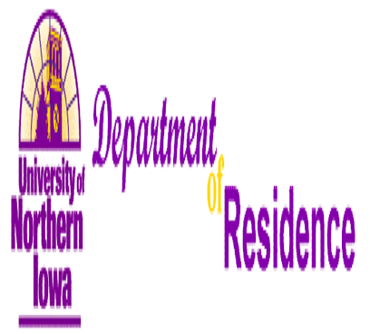
Position Announcement
Assistant/Associate Professor of Mathematics Education

Position
The University of Northern Iowa provides a high quality and diverse educational experience, purposefully guiding students to find and develop their strengths and prepare them for success after college. Building on its historic excellence in teacher education, the university has developed outstanding programs in business, natural sciences, humanities and fine arts, and social and behavioral sciences with advanced degrees available in many programs.

One of three state universities, UNI enjoys national recognition for its high educational standards. U.S. News and World Report ranked UNI in the top three among Midwest public universities for the past 17 years.

The university’s size -- just more than 12,200 students -- allows it to offer faculty, facilities and academic choices of a large university, while retaining a friendly, small-college atmosphere on a compact, park-like campus.

For more information, visit www.uni.edu.

UNI is a smoke-free campus.

The Department of Mathematics invites applications and nominations for a tenure-track position in K-8 or 5-12 mathematics education at the assistant or associate professor level. The successful candidate will be expected to teach a broad spectrum of courses in mathematics education throughout the undergraduate curricula and in master’s degree programs. There are expectations for scholarship leading to publication, grant writing, curriculum development, and professional service. Scholarship that includes student participation is encouraged. A standard teaching load is 18 credit hours per academic year. The department has a strong tradition of excellence in teaching and supports scholarship and research in mathematics and mathematics education. The department encourages applications from persons of color, women, persons living with disabilities, and veterans.

Qualifications
Candidates must possess a doctorate in mathematics education (ABDs will be considered with evidence of degree completion by August 2013), an ability and interest in maintaining a superior teaching record, and an emerging or established record of scholarship. Preference will be given to applicants who have teaching experience in K-12 classrooms, a history of working with K-12 schools, recent collegiate teaching experience, or experience in reform-based curricula. Pre-employment background checks are required.

Department and Its Direction
The Department of Mathematics consists of 26 tenured and tenure-track faculty members, including 10 mathematics educators. The department offers master’s degrees in mathematics and mathematics education. It also offers undergraduate degrees with concentrations in mathematics, statistics and actuarial science, and mathematics education (K-8 minor and secondary teaching). The University hosts a STEM (Science, Technology, Engineering, and Mathematics) Hub, which is part of a state-funded initiative to promote and improve math and science education. The Center for Teaching & Learning Mathematics (CTLM) at UNI also provides leadership for professional development in the state. More information may be obtained at the web sites of the University (www.uni.edu), the Department (www.uni.edu/math), STEM Hub (www.uni.edu/stemed), and CTLM (www.uni.edu/ctlm).

Appointment Date and Salary
Appointment will be effective in August 2013. Salary will be competitive and supplemented by excellent fringe benefits. Additional support for research, such as reduced teaching loads and summer funding, is available on a competitive basis.

Application Procedure
For full consideration, complete applications must be received by November 2, 2012. To apply, visit http://jobs.uni.edu. Inquiries may be sent to the Search Committee Co-Chair, Elizabeth Hughes, at elizabeth.hughes@uni.edu, or 319-273-6969; Fax: 319-273-2546.
The University of Northern Iowa is an Equal Opportunity Employer with a comprehensive plan for affirmative action.

